

KAUNO TECHNOLOGIJOS UNIVERSITETAS

Informatikos fakultetas

T120B169 App Development for Smart Mobile Systems

Report of individual task

**Blood connect app**

**Dėstytojas: Rytis Maskeliūnas**

**Studentas: Kasparas Giniūnas IFF-6/4**

KAUNAS, 2018

Table of contents

Introduction 3

Design of application 4

1. Home page 4

2. Become a donor 4

3. Search for donors 5

Implementation 6

# Introduction

Blood connnect app is a mobile application connects patients with bood donors. You can use this app to find donors by your blood type or by specific blood type. When app is opened, user enters his name and email adress to continue using the app. After registration user can either become a donor and put his information to a donors database or look for donors by his blood type, city e.g.

# Design of application

## Home page

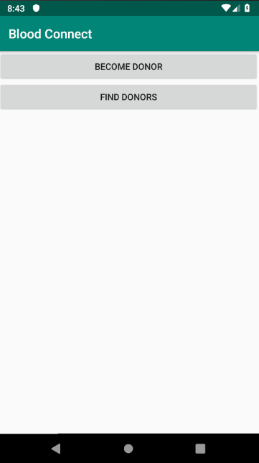

When home page is loaded, there are four buttons.

Button calles „Profile“ lets user create his own profile , so other users can see information the user.

Button called „Search for donors“ opens up list of all registered blood donors.

Button called „Become a donor“ puts user into a donors‘ data base so other can find the user in a donors list.

Button called „Log in“ opens up log in/registration page.

## Become a donor

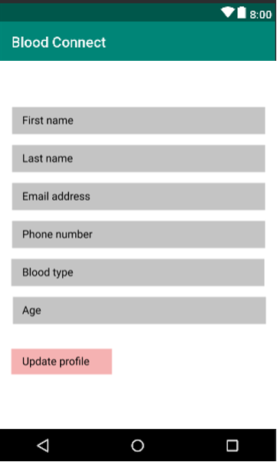

In a „Become a donor“ page user can update his personal information and put his information into donors database so other users can find him.

## Search for donors

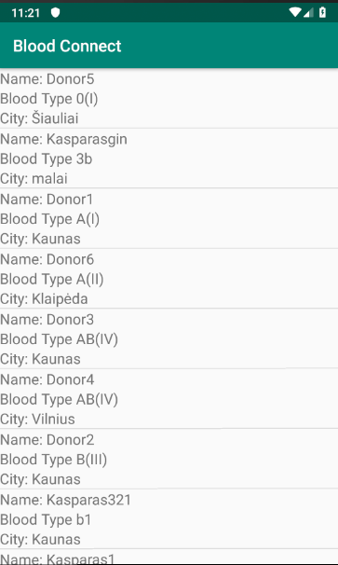

When „Search for donors“ window is opened user can view list of all donors in the database. When pressed on a specific donor, window with that donor‘s personal information opens.

# Implementation

So far these implementation steps have been acomplished:

* *Entity* class *Donor* implemented which describes each donor;

**package** edu.ktu.bloodconnect;  
  
**import** java.io.Serializable;  
  
**public class** Donor **implements** Serializable {  
  
 **private** String **firstName**;  
 **private** String **lastName**;  
 **private** String **phoneNumber**;  
 **private** String **bloodType**;  
 **private int age**;  
 **private** String **email**;  
 **private** String **city**;  
   
 **public** Donor(){  
  
 }  
  
 **public** Donor(String firstName, String lastName, String phoneNumber, String bloodType, **int** age, String email, String city) {  
  
 **this**.**firstName** = firstName;  
 **this**.**lastName** = lastName;  
 **this**.**phoneNumber** = phoneNumber;  
 **this**.**bloodType** = bloodType;  
 **this**.**age** = age;  
 **this**.**email** = email;  
 **this**.**city** = city;  
 }  
  
 **public** String getFirstName() {  
 **return firstName**;  
 }  
  
 **public** String getLastName() {  
 **return lastName**;  
 }  
  
 **public** String getPhoneNumber() {  
 **return phoneNumber**;  
 }  
  
 **public** String getBloodType() {  
 **return bloodType**;  
 }  
  
 **public int** getAge() {  
 **return age**;  
 }  
  
 **public** String getEmail() {  
 **return email**;  
 }  
  
 **public** String getCity() {  
 **return city**;  
 }  
}

* Home page. When opening app for the first time user has to put his name and email address to continue using the app. After registration every time when opening the app, homepage loads. *SharedPreferences* instance saves user email address so user can stay logged in.

**package** edu.ktu.bloodconnect;  
  
**import** android.content.Context;  
**import** android.content.Intent;  
**import** android.content.SharedPreferences;  
**import** android.os.Bundle;  
**import** android.support.v7.app.AppCompatActivity;  
**import** android.view.View;  
**import** android.widget.Button;  
**import** android.widget.EditText;  
**import** android.widget.TextView;  
  
  
**public class** HomePageActivity **extends** AppCompatActivity {  
  
 **private** Context **context** = **this**;  
 **private** Button **becomeDonorButton**;  
 **private** Button **showDonorsButton**;  
 **private** EditText **registerName**;  
 **private** EditText **registerEmail**;  
 **private** Button **registerButton**;  
  
  
  
 @Override  
 **public void** onCreate(Bundle savedInstanceState){  
 **super**.onCreate(savedInstanceState);  
  
 SharedPreferences sharedPreferences = getSharedPreferences(Constants.***SHARED_PREFS***, ***MODE_PRIVATE***);  
 **boolean** isRegistered = sharedPreferences.getBoolean(Constants.***IS_REGISTERED***, **false**);  
  
  
 **if**(isRegistered){  
 loadHomePage();  
 } **else** {  
 loadRegistrationPage();  
 }  
 }  
  
 **private void** loadHomePage(){  
 setContentView(R.layout.***home_page_activity***);  
 **becomeDonorButton** = (Button)findViewById(R.id.***becomeDonorButton***);  
 **becomeDonorButton**.setOnClickListener(**new** View.OnClickListener() {  
 @Override  
 **public void** onClick(View v) {  
 Intent intent = **new** Intent(**context**, BecomeDonorActivity.**class**);  
 intent.putExtra(**"flag"**, **true**);  
  
 **context**.startActivity(intent);  
 }  
 });  
  
 **showDonorsButton** = (Button)findViewById(R.id.***showDonorsButton***);  
 **showDonorsButton**.setOnClickListener(**new** View.OnClickListener() {  
 @Override  
 **public void** onClick(View v) {  
 Intent intent = **new** Intent(**context**, ShowDonorsActivity.**class**);  
 intent.putExtra(**"flag"**, **true**);  
  
 **context**.startActivity(intent);  
 }  
 });  
 }  
  
 **private void** loadRegistrationPage(){  
 setContentView(R.layout.***activity_register***);  
  
 **registerButton** = (Button)findViewById(R.id.***start_button***);  
 **registerName** = (EditText)findViewById(R.id.***register_name***);  
 **registerEmail** = (EditText)findViewById(R.id.***register_email***);  
  
 **registerButton**.setOnClickListener(**new** View.OnClickListener() {  
 @Override  
 **public void** onClick(View v) {  
 saveRegistration();  
 Intent intent = **new** Intent(**context**, HomePageActivity.**class**);  
 intent.putExtra(**"flag"**, **true**);  
  
 **context**.startActivity(intent);  
 }  
 });  
 }  
  
 **private void** saveRegistration(){  
 SharedPreferences sharedPreferences = getSharedPreferences(Constants.***SHARED_PREFS***, ***MODE_PRIVATE***);  
 SharedPreferences.Editor editor = sharedPreferences.edit();  
  
 editor.putString(Constants.***EMAIL***, **registerEmail**.getText().toString());  
 editor.putString(Constants.***NAME***, **registerName**.getText().toString());  
  
 editor.putBoolean(Constants.***IS_REGISTERED***, **true**);  
 editor.apply();  
 }  
}

 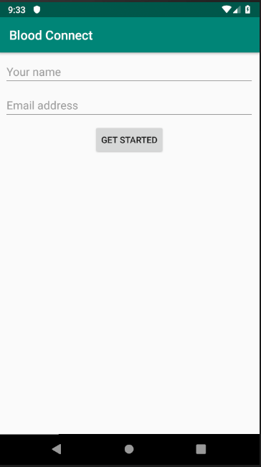

* Becoming donor page. User can put himself in a donor by presssing „Become donor“ button and filling personal details form. When button „Submit“ is pressed users information is put in the database;

**package** edu.ktu.bloodconnect;  
  
**import** android.content.Context;  
**import** android.content.Intent;  
**import** android.content.SharedPreferences;  
**import** android.os.Bundle;  
**import** android.support.v7.app.AppCompatActivity;  
**import** android.text.TextUtils;  
**import** android.view.View;  
**import** android.widget.Button;  
**import** android.widget.EditText;  
**import** android.widget.TextView;  
**import** android.widget.Toast;  
  
**import** com.google.firebase.database.DatabaseReference;  
**import** com.google.firebase.database.FirebaseDatabase;  
  
**public class** BecomeDonorActivity **extends** AppCompatActivity {  
  
 **private** Button **becomeDonorButton**;  
 **private** Context **context** = **this**;  
 **private** EditText **firstName**;  
 **private** EditText **lastName**;  
 **private** EditText **phone**;  
 **private** EditText **bloodType**;  
 **private** EditText **age**;  
 **private** EditText **city**;  
 **private** EditText **email**;  
 **private** Donor **donor**;  
 **private** DatabaseReference **databaseReference**;  
  
 @Override  
 **public void** onCreate(Bundle savedInstanceState){  
 **super**.onCreate(savedInstanceState);  
 setContentView(R.layout.***become_donor_activity***);  
  
 **firstName** = (EditText)findViewById(R.id.***firstNameInput***);  
 **lastName** = (EditText)findViewById(R.id.***lastNameInput***);  
 **phone** = (EditText)findViewById(R.id.***phoneNumberInput***);  
 **bloodType** = (EditText)findViewById(R.id.***bloodTypeInput***);  
 **age** = (EditText) findViewById(R.id.***ageInput***);  
 **city** = (EditText)findViewById(R.id.***cityInput***);  
 **email** = (EditText)findViewById(R.id.***emailInput***);  
  
 **databaseReference** = FirebaseDatabase.*getInstance*().getReference(**"donors"**);  
  
 **becomeDonorButton** = (Button)findViewById(R.id.***createButton***);  
 **becomeDonorButton**.setOnClickListener(**new** View.OnClickListener() {  
 @Override  
 **public void** onClick(View v) {  
 uploadData();  
 }  
 });  
  
 loadData();  
 }  
  
 **private void** loadData(){  
 SharedPreferences sharedPreferences = getSharedPreferences(Constants.***SHARED_PREFS***, ***MODE_PRIVATE***);  
  
 **firstName**.setText(sharedPreferences.getString(Constants.***NAME***, **""**));  
 **email**.setText(sharedPreferences.getString(Constants.***EMAIL***, **""**));  
 }  
  
 **private void** uploadData(){  
  
 **if**(**firstName**.getText().length() <= 0 || **lastName**.getText().length() <= 0 || **phone**.getText().length() <= 0  
 || **bloodType**.getText().length() <= 0 || **age**.getText().length() <= 0  
 || **city**.getText().length() <= 0 || **email**.getText().length() <= 0 ){  
 Toast.*makeText*(getApplicationContext(), **"All fields must be filled"**, Toast.***LENGTH_SHORT***).show();  
 } **else** {  
  
 **donor** = **new** Donor(**firstName**.getText().toString(), **lastName**.getText().toString(), **phone**.getText().toString(), **bloodType**.getText().toString(),  
 Integer.*parseInt*(**age**.getText().toString()), **email**.getText().toString(), **city**.getText().toString());  
  
 **databaseReference**.child(**email**.getText().toString().replace(**"."**, **","**)).setValue(**donor**);  
  
 Toast.*makeText*(getApplicationContext(), **"You successfully became a donor!"**, Toast.***LENGTH_SHORT***).show();  
 }  
 }  
}

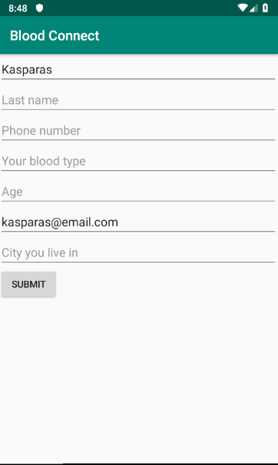

* Donors list page. When opened user can look through the list of all donors or find a specific donor.

**package** edu.ktu.bloodconnect;  
  
**import** android.content.Intent;  
**import** android.os.Bundle;  
**import** android.support.annotation.NonNull;  
**import** android.support.v7.app.AppCompatActivity;  
**import** android.view.View;  
**import** android.widget.AdapterView;  
**import** android.widget.Button;  
**import** android.widget.ListView;  
**import** android.widget.TextView;  
  
**import** com.google.firebase.database.DataSnapshot;  
**import** com.google.firebase.database.DatabaseError;  
**import** com.google.firebase.database.DatabaseReference;  
**import** com.google.firebase.database.FirebaseDatabase;  
**import** com.google.firebase.database.Query;  
**import** com.google.firebase.database.ValueEventListener;  
  
**import** java.util.ArrayList;  
**import** java.util.List;  
  
**public class** ShowDonorsActivity **extends** AppCompatActivity {  
  
 **private** ListView **donorList**;  
 **private** ListAdapter **adapter**;  
 **private** DatabaseReference **databaseReference**;  
  
 @Override  
 **public void** onCreate(Bundle savedInstanceState) {  
 **super**.onCreate(savedInstanceState);  
 setContentView(R.layout.***show_donors_activity***);  
  
 **donorList** = (ListView) findViewById(R.id.***donor_list***);  
  
 **databaseReference** = FirebaseDatabase.*getInstance*().getReference().child(**"donors"**);  
  
 getDonorList();  
 }  
  
 **private void** getDonorList(){  
  
 **final** ArrayList<Donor> donors = **new** ArrayList<>();  
 Query donorsQuery = **databaseReference**.orderByChild(**"bloodType"**);  
  
 donorsQuery.addListenerForSingleValueEvent(**new** ValueEventListener() {  
 @Override  
 **public void** onDataChange(@NonNull DataSnapshot dataSnapshot) {  
 **if**(dataSnapshot.exists()){  
 **for**(DataSnapshot singleSnapshot : dataSnapshot.getChildren()){  
 Donor donor = singleSnapshot.getValue(Donor.**class**);  
 donors.add(donor);  
 }  
 }  
 **adapter** = **new** ListAdapter(ShowDonorsActivity.**this**, donors);  
  
 **donorList**.setAdapter(**adapter**);  
  
 **donorList**.setOnItemClickListener(**new** AdapterView.OnItemClickListener() {  
 @Override  
 **public void** onItemClick(AdapterView<?> parent, View view, **int** position, **long** id) {  
 Intent intent = **new** Intent(getApplicationContext(), DonorActivity.**class**);  
 intent.putExtra(**"Donor"**, donors.get(position));  
 startActivity(intent);  
 }  
 });  
 }  
  
 @Override  
 **public void** onCancelled(@NonNull DatabaseError databaseError) {  
  
 }  
 });  
 }  
}



* Donor‘s details page. When pressed on a specific donor in a donor‘list, a page with selected donor‘s information opens, to find more information about donor.

**package** edu.ktu.bloodconnect;  
  
**import** android.support.v7.app.AppCompatActivity;  
**import** android.os.Bundle;  
**import** android.widget.TextView;  
  
**import** org.w3c.dom.Text;  
  
**public class** DonorActivity **extends** AppCompatActivity {  
  
 **private** TextView **displayName**;  
 **private** TextView **displayPhoneNumber**;  
 **private** TextView **displayBloodType**;  
 **private** TextView **displayAge**;  
 **private** TextView **displayEmail**;  
 **private** TextView **displayCity**;  
  
 @Override  
 **protected void** onCreate(Bundle savedInstanceState) {  
 **super**.onCreate(savedInstanceState);  
 setContentView(R.layout.***activity_donor***);  
  
 **displayName** = (TextView)findViewById(R.id.***display_name***);  
 **displayPhoneNumber** = (TextView)findViewById(R.id.***display_phoneNumber***);  
 **displayBloodType** = (TextView)findViewById(R.id.***display_bloodType***);  
 **displayAge** = (TextView)findViewById(R.id.***display_age***);  
 **displayEmail** = (TextView)findViewById(R.id.***display_email***);  
 **displayCity** = (TextView)findViewById(R.id.***display_city***);  
  
 Donor donor = (Donor)getIntent().getSerializableExtra(**"Donor"**);  
  
 **displayName**.setText(donor.getFirstName() + **" "** + donor.getLastName());  
 **displayPhoneNumber**.setText(donor.getPhoneNumber());  
 **displayBloodType**.setText(donor.getBloodType());  
 **displayAge**.setText(String.*valueOf*(donor.getAge()));  
 **displayEmail**.setText(donor.getEmail());  
 **displayCity**.setText(donor.getCity());  
 }  
}

